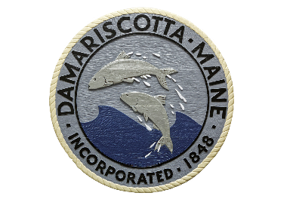

Agenda
Joint Meeting

Select Board Meeting/Budget Committee
Town of Damariscotta, Maine
December 21, 2022
4:30 PM
Join Zoom Meeting: https://us02web.zoom.us/j/87878201039
Meeting ID: 878 7820 1039 Passcode: Dama22

- Pledge of Allegiance

- Call Select Board Meeting to Order

- Call Budget Committee Meeting to Order

- Official Items

- Discussion Items

  - FY 24 Personnel Costs
    - Proposed wages
    - Proposed benefits
  - Overview of anticipated budget impacts
      - COLA – Social Security COLA 2023: 8.7% ↑
      - New England Consumer Price Index (December 2022) 6.1%↑
      - Insurance: 4.5% ↑in CY 2023
      - Retirement: no change. Next adjustment will be in FY 25.

- Select Board/Budget Committee Items

- Adjournment

